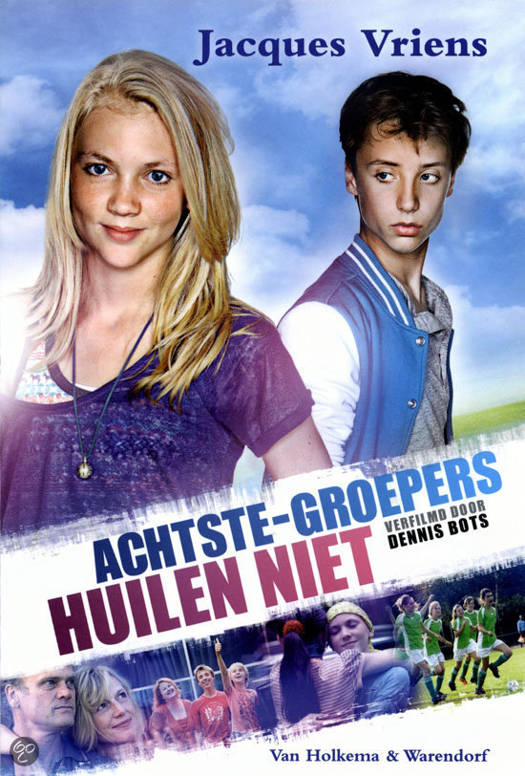[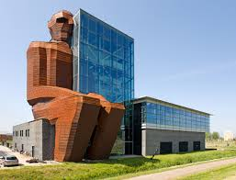](http://www.google.nl/url?sa=i&rct=j&q=&esrc=s&frm=1&source=images&cd=&cad=rja&uact=8&ved=0CAcQjRw&url=http://imdbv.nl/Projecten/Cultuur-uitgaan&ei=V6NIVNm-Ee2d7gaYvIHoCQ&bvm=bv.77880786,d.ZGU&psig=AFQjCNHzMvm70hu_NTfyqg0UiY6ZPU6T0w&ust=1414132878461625)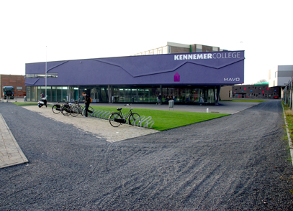[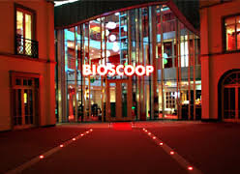](http://www.google.nl/url?sa=i&rct=j&q=&esrc=s&frm=1&source=images&cd=&cad=rja&uact=8&ved=0CAcQjRw&url=http://movieunlimitedbioscopen.nl/aspx/algemeen/informatie/routebeschrijving.aspx?cinema%3Dalmelo&ei=cqJIVKDyHYiV7AatgYHQCQ&bvm=bv.77880786,d.ZGU&psig=AFQjCNEY8UjfEgdjyECRRNTU4IsuWWb2JA&ust=1414132670077605)

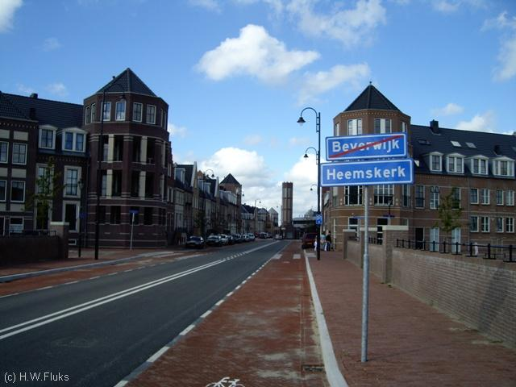[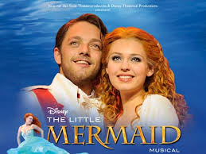](http://www.google.nl/url?sa=i&rct=j&q=&esrc=s&frm=1&source=images&cd=&cad=rja&uact=8&ved=0CAcQjRw&url=http://www.kras.nl/vakantie/nederland/reis-52504/musicalarrangement--the-little-mermaid--utrecht&ei=1KNIVJCKJePY7AbnzICwDQ&bvm=bv.77880786,d.ZGU&psig=AFQjCNGfXcB6nLplZOMr6mmCfdDGw2-Paw&ust=1414133052080326)